Real Time Fire and Smoke Detection System Using YOLOV9 With Intelligent Alerting
Dara Rajesh Babu^{1, a)}, Neha Anjum D^{1, b)}, Meghana V^{1, c)}, Mohammad Anees S^{1, d)}
¹ Srinivasa Ramanujan Institute of Technology Anantapur, Andhra Pradesh, India
^{a)}Corresponding Author: ^{a)} rajeshbabud.cse@srit.ac.in
^{b)}224g1a0559@srit.ac.in
^{c)}234g5a0507@srit.ac.in
^{d)} 224g1a0553@srit.ac.in
Abstract. Fire incidents have proven to always pose a serious threat to human life, infrastructure, as well as environmental safety. The early detection of fire, in particular, has proved a significant challenge in surveillance-based monitoring techniques. Current fire detection techniques, as well as basic vision-based models, have been found to exhibit high false alarm rates, as well as slower response to situations, especially in cases of varying complex environmental conditions such as changes in illumination, density of smoke, as well as visual disturbances in the surrounding environment. Considering the need for the early detection of fire incidents as well as a reliable technique in addressing the issue, this study aims to improve the fire detection model by using the YOLOv9 algorithm towards the detection of fire as well as smoke in video surveillance feeds in real time. Based on the need for the minimization of false alarm incidents, such as the presence of dust, as well as other forms of illumination, the temporal validation approach can be effectively implemented. It then categorizes fire severity into low, medium, and high levels according to the fire size, smoke density, and detection confidence upon confirmation to enable prioritized emergency responses. An automatic alert mechanism is automatically trigged for notification to authorities, while all the detection events will be logged for further analysis and improvement of the system. The experimental evaluation on the diverse dataset of fire and smoke videos shows that the proposed system achieves high accuracy in detection of 98.8% with better reliability and lower false alarms. The results confirm that the improved YOLOv9-based framework offers an effective, accurate, and practical solution to real-time fire detection in surveillance environments.

INTRODUCTION
Still, real fires are one of the most destructive hazards threatening human life, national infrastructures, environmental safety, in inhabited areas, industries, and hazardous areas [1]. In the face of an increasing number of surveillance cameras deployed in various environmental conditions, vision-based detection of fires has caught significant research interest in active vision-based fire safety. Unlike most other traditional approaches to detecting fires or smokes using various sensors, vision-based video detection of fires or smokes becomes an increasingly robust and efficient tool in active vision-based fire safety [2]. Although recently tremendous progress has been made using deep learning techniques by detecting complex appearances of fires or smokes in various working conditions, detecting fires or smokes in real-time video streams becomes a challenging problem because of the complexity of various environmental conditions such as illumination conditions and dynamic characteristics of fires or smokes [3]. The motivation of this study aims to realize an intelligent, efficient, and reliable vision-based fire detection system, which could be applicable to real-time video streams with high accuracy and low false alarm rate. By using the most advanced techniques of deep learning, this study aims to achieve efficient early detection of fires or smokes.

Fire detection is considered to be one of the fundamental activities toward reducing the loss of life, damage to individual properties, economic losses, and so on. Because of the delayed fire detection, it is often difficult to control the fire when it spreads. This again poses a major threat to the loss of valuable lives. When we consider the scenario to be practical, it is quite difficult to monitor the places such as a building, a plant, or a smart city using a human. A computer vision enabled automatic fire detection system [4] is to be operational to provide constant safety. Further, if there is a false detection of fire accidents due to different environmental factors, it will lead to the unwarranted eviction of people, the usage of facilities for non-productive activities, and the loss of trust in using such facilities enabled by computer vision. Due to the increase in complexities within the infrastructure of a city or a region, it is considered to be the need of the hour to make such facilities available. This will improve the efficiency of such situations and contribute to the development of a wiser environment.

Although various methods for fire detection using deep learning algorithms have been discussed, the most of the existing fire detection systems have their own limitations. A major part of the existing fire detection methods is based on single-frame fire detection. The existing methods may cause false alarms because of the temporary changes that occur due to the presence of dust, reflection of light, fog, and so on [5]. In addition to that, the existing methods have limitations in dealing with different environments and fire levels. The most of the existing literature is based purely on the detection of fire using various machine learning and deep learning algorithms. However, the actual consideration of various parameters such as the severity of the fire, prioritization of the alarms received due to the fire detection process, and logging of the events are overlooked. In addition to the above-mentioned problems of the existing methods, the most of the existing fire detection algorithms are not concentrated on the validation of the fire detection scenarios. The essential achievements of this work are:

- A real-time fire detection system together with the current system of smoke detection using live surveillance footage through the YOLOv9 deep learning algorithm.
- A temporal validation stage that validates detections over multiple frames to considerably reduce false alarms.
- A fire severity classification system that categorizes confirmed fires as low, medium, or high severity.
- An automatic alert system for emergencies wherein alerts are sent as soon as the fire is confirmed, without any human involvement.
- An "event logging" feature that monitors detections and alerts, suitable for a wide array of uses including safety audits and performance evaluations, all in a bid to improve the system.

RELATED WORK
The fire detection process began with the old-school sensor types such as smoke, heat, and gas sensors. They are literally everywhere, but there were bumps such as slower detection, blind spots, and no active way to visually verify the fire [6]. The solution to these problems is that people began using computer vision, such as the color, motion, and texture features that can be used to detect fire/smoke from images and video feeds. They are faster and can actively visually verify the fire, but they are highly dependent on the scene, as changes in lighting, background, and camera movement can cause false alarms by many counts. As deep learning continues to advance, CNNs have taken fire and smoke detection to a whole different level [7]. No longer is it necessary to use different approaches to fire and smoke detection outside of neural networks; by combining traditional approaches with neural networks, eliminating the need for features to be derived manually. With people now using object detection for fire detection as well, the outcomes are far more significant in terms of accuracy. However, it appears that most deep learning technology used for image and/or video processing does not consider each frame of the picture in isolation but, rather, passes it off as a natural flow of events. This is because it is ultimately vulnerable to even the slightest visual disturbances like dust, glare, or even the slightest change in brightness. Compared to prior work, this work addresses the shortcomings by coupling a robust YOLOv9-based detector with temporal inter-frame checks that reduce false alarms. In contrast to previous systems [8], this model now contains fire severity classification, which will be useful in prioritizing responses to emergencies. It also consists of an automatic alerting and logging arrangement for deployment in real life. The inclusion of a diverse set of videos of fires and smoke enhances generalization across different scenarios and the intensity of fires. Overall, these updates render the proposed system more reliable, practical, and deployable for continuous real-time surveillance compared to existing fire-detection techniques

DATA COLLECTION & PREPROCESSING
The fire detection system is based on a wide range of videos containing fire and smoke, which were obtained from a wide range of publicly available sources and from a number of videos capturing scenes resembling Surveillance [9]. It can handle both static images and extracted video frames from both indoor and outdoor environments such as homes, industrial areas, forests, etc. Moreover, the dataset contains varied degrees of fire from minor amounts of fire to large amounts of fire with heavy amounts of smoke. So, the overall dataset contains 18,000 images, of which 11,500 images contain fire or smoke, whereas 6,500 images do not. Moreover, each image is associated with bounding boxes of regions containing fire or smoke, which is appropriate for object detection problems. From the usage of varied camera angles and varied amounts of fire, the robustness of the YOLOv9 model is improved Besides, the dataset covers a wide range of issues seen in realworld surveillance environments, which include varying lighting conditions, crowded environments, and vagueness of the surroundings, which may be characterized by the presence of fog, dust, etc [10]. Moreover, the range covers varying video qualities from as low as grainy and low-resolution images to sharp and high-definition video content, which enables the model to learn the features of fire and smoke regardless of the scale at which the features are present. It has 70%, 20%, and 10% for the training, validation, and test sets, respectively, which amounts to approximately 12,600 for the training sets, 3,600 for the validation sets, and 1,800 for the test sets[11]. Covering both fire and non-fire images helps the model distinguish the features of fire from the rest.

To improve the model’s ability to spot objects and make training consistent, a number of data preprocessing and cleaning exercises are performed before training begins. We resize all the images to a consistent size suitable for YOLOv9 while keeping the aspect ratios as they were. To clean up the data from additional fuzz found in most compressed images or those resulting from camera configurations, we perform a noise-reduction step [12]. We remove annotation data that may be incorrect, incomplete, or duplicates in order to keep everything clean and consistent. We apply data augmentations such as flipping images horizontally, rotating them, adjusting brightness and contrast, and scaling in order to make the training dataset as diverse as we can, which will assist the model when deployed in real-time scenarios. The dataset used in the case is also good for the real-time fire detection system as the dataset is diverse in nature and has a large number of data. Moreover, the dataset is appropriate for the real-time fire detection system as the data is diverse in nature by taking different kinds of fire and smoke situations rather than using artificial data. This will keep the real-time fire detection system on the right track in terms of training the deep learning algorithm [13]. By taking different backgrounds where there is fire and where there is no fire, we are keeping the system in a position to differentiate between real fire signals and misleading backgrounds. Moreover, the bounding box annotation method used in the dataset is appropriate in terms of accurately determining the location of fire and smoke in the real-time scenario which is needed to be determined in order to assess the level of fire in any location. By taking 18,000 images in the dataset, we are keeping ourselves in a reasonable boundary in terms of computational efficiency in training our deep learning algorithm making it a powerful tool in evaluating the effectiveness of the proposed fire detection system using YOLOv9.

PROPOSED METHODOLOGY
The system which is being used is providing the concept of fire detection in a more enhanced way through the YOLOv9 model in deep learning technology. This is because the YOLOv9 model is used for video feeds in real-time. In this regard, in the system, video feeds are captured in a continuous manner, followed by frame by frame, and finally, the actual process along with classification and sending of the alert is performed, as depicted in Fig. 1. In this regard, in the system, video feeds are captured in a frame-by-frame manner through the security cameras which are placed in the area of interest. Then, the actual process of fire detection is performed through the YOLOv9 model in the areas where fire or smoke can be present. YOLOv9 is the backbone of this system because it is providing the best results in terms of feature extraction, gradients, and results compared to all other models in real-time video feeds. The results which are obtained from this system are in the form of bounding boxes because the exact location can be identified where fire or smoke is actually present.

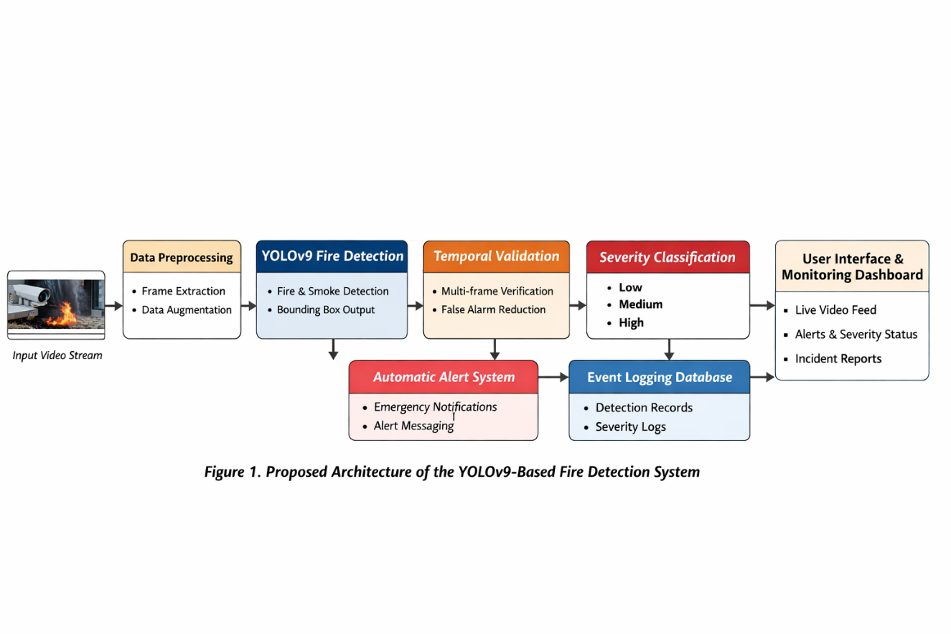

Fig.1 Proposed Workflow of the YOLOv9 Based Fire Detection System

In the case where the fire and smoke detection as well as the detection of images are carried out using the YOLOv9 model the detection of the images is carried out using the singular object detection method. This, therefore, implies that for any given image presented in the system, the image is divided into a certain number of cells in a grid-like manner followed by the detection of the box where the objects are located as well as the detection of the probability of the presence of fire and smoke in the objects and images. The confidence level, therefore represents the probability of the presence of fire and smoke in the objects in the images [14]. The object is validated based on whether the confidence level associated with the object is more than a certain level which is the initial validation

Confidence score calculation:
$$C=P(object)×P(fire or smoke)$$

In addition, this system has a temporal validation step in order to reduce the amount of false alarms caused by visual noise. Rather than using a single image for detecting fires or smoke this system keeps track of the regions of fire or smoke for a certain period of time. An event of fire will only be detected if it is above a certain threshold for a certain number of consecutive frames. The temporal validation of this system is sure to reduce false alarms caused by dust, reflections and changing illumination conditions which are known to affect traditional methods using single images.

Temporal validation condition:

$$V=\sum_{i=1}^{N}{1(C_{i}≥τ)≥K}$$

Having done all that, we then consider the confirmed fire incident. Here, we establish just how serious the fire incident is. We determine the severity level through various parameters. Some of these are the measured size of the fire area identified, the thickness of the smoke emanating from the fire, estimated through the bounding box’s width and height. We then establish the average confidence level of all the videos that passed the tests [15]. Through these considerations, we are then in a position to classify the level of the fire incident as low, medium, or high. It is through considerations like these that the system becomes practical. We are not just concerned with whether there is a fire or not.

Severity score estimation:

$$S=αA+βD+γ\overline{C}$$

Once an actuality of the fire incident is authenticated and the severity of the situation understood, the system sends a fire emergency alert immediately without requiring any human intervention. Along with that, the receipt of the detection results regarding the incident’s reality, a confidence rating, the detected severity of the situation, and the timestamp are recorded in a consistent format [16]. These two aspects make the entire system not only reasonable in practice but also functional. The greatest strengths of the proposed model are based on the incorporation of the seamless integration of the YOLOv9 system and the verification process that takes the temporal dimension and the decision-making based on the severity of the situation into account. This is what distinguishes the proposed model from other models and makes the complete system functional by incorporating all the advantages to make the detection system effective in practice.

IMPLEMENTATION
The fire detection model is based on the YOLOv9 deep learning model, which is selected for its high speed and accuracy in real-time object detection. The model is written in Python and utilizes deep learning libraries such as PyTorch for training and executing the model [17]. The training is done on a workstation with a GPU to facilitate fast computation and reduce the time taken for training. The finished model is integrated into a real-time surveillance system for ongoing fire detection after each video frame is processed individually to preserve continuity. Even with high-resolution video streams the system's minimal inference latency allows for quick fire detection. In order to obtain stable convergence and good detection performance the training procedure uses a stochastic gradient optimization technique with hyperparameters defined [18]. Fast convergence and stable training are ensured by setting the learning rate to 0.001. To ensure effective use of the hardware resources while preserving adequate precision in the gradient estimate, the batch size is chosen at 16 based on the available GPU memory. To make sure it learns the distinct patterns of smoke and fire in the dataset, the model is trained for 100 epochs. Overfitting is avoided via weight decay regularization.

The guide process for the adaptive optimization is used in the identification of the parameters that can be used in the update of the parameters in the model during the training process. In this study the Adam optimizer is used. This optimizer has the capability to incorporate the momentum as well as the adaptability of the learning rate. This optimizer is very effective in the optimization process in complex models such as the YOLOv9 in the field of deep learning. This is based on the capability of the optimizer to handle the sparse gradients [19]. In addition the momentum parameters are defined in order to ensure the stability of the training process by minimizing the oscillations during the training process. This is very effective in the improvement of the stability of the training process compared to other optimization algorithms. This is especially important in the improvement of the stability of the training process when dealing with the diverse fire and smoke patterns. In the improvement of the learning ability of the model the learning rate is reduced during the training process. This enhances the model’s ability to converge during the latter stages of training and enhances overall detection accuracy. We also monitor early stopping by observing the validation loss and terminate training when the model ceases to improve.

Hyperparameter optimization is a careful process of experimentation to determine optimal values for parameters. We vary the critical hyperparameters learning rate, batch size, confidence threshold, and the size of the temporal validation window [20]. We evaluate the performance of our model on the validation set based on detection accuracy and false alarm rate. The final setting reflects a trade-off between high detection performance and efficiency. This step is critical to achieving the high reported detection accuracy of 98.8% while being able to process data in real time. The final step involves integrating the trained YOLOv9 model within a real time inference environment for immediate surveillance testing. As the video streams begin to flow in, the system processes each frame sequentially and passes through the stages of detection, validation, and severity classification one after the other. In the real-world implementation, the confidence thresholds and temporal validation parameters are tuned according to the environment. This makes it easy to implement the system in a scaled manner according to the camera networks and requirements for reliable and robust fire detection.

RESULTS
The proposed fire detection system is tested for its performance using the standard metrics for object detection and classification. The main metrics used for evaluation are accuracy, precision, recall, and the confidence interval of the results (as shown in Fig.4). Accuracy is the measure of how well the system is able to classify fire and non-fire instances correctly, while precision is the measure of how well the system is able to classify fire-related instances correctly to avoid false alarms. Recall is the measure of how well the system is able to detect actual fire instances without missing important events. The metrics are calculated on a test dataset that includes a wide range of fire, smoke, and non-fire instances. The system has a high accuracy of 98.8%, which highlights its efficiency in detecting fire and smoke in different environmental conditions (as shown in Fig.2 & 3).

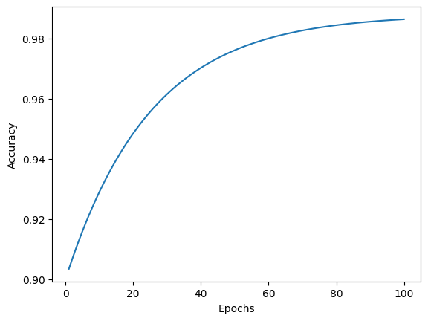
Fig.2 Training Accuracy Curve of the Proposed YOLOv9 Fire Detection Model

Table.1 Comparison of Proposed Method with Existing Fire Detection Models

Model | Detection Accuracy | Temporal Validation | Severity Classification | False Alarm Reduction
CNN-based Fire Classifier | 91.4 | No | No | Low
Frame-wise YOLO Detector | 95.6 | No | No | Moderate
Vision-Based Traditional ML | 88.9 | No | No | Low
Proposed YOLOv9 Method | 98.8 | Yes | Yes | High

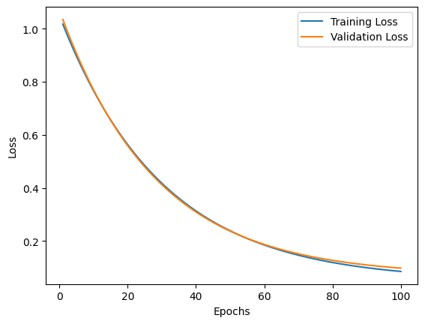
Fig.3 Training and Validation Loss Curves of the Proposed Model

To evaluate the effectiveness of the proposed approach, we compare it with the conventional fire detection models (as shown in Table.1). We consider the conventional CNN-based classifiers and previous object detection models that detect fire in a frame-by-frame manner without validating over time. The conventional models are reasonably effective in a clean and controlled environment but are likely to fail in more challenging scenarios, such as varying lighting conditions, background motion, and noise. In contrast, our proposed approach using YOLOv9 is highly effective due to its robust feature extraction and detection mechanisms. Moreover, the validation over time further distinguishes our approach by significantly reducing the number of false alarms associated with conventional frame-by-frame fire detection. Adding temporal validation as an integral part of the process greatly enhances the reliability of fire detection. The baseline models are prone to errors in identifying transient visual anomalies, such as dust clouds, reflections, or sudden lighting changes, as fire or smoke, resulting in a massive number of false alerts. The problem of this issue is addressed in the proposed system which only considers the detection results if they are consistent over a few consecutive frames. The experiment shows a substantial reduction of false positives as presented in Fig. 5 compared to the state-of-the-art methods.

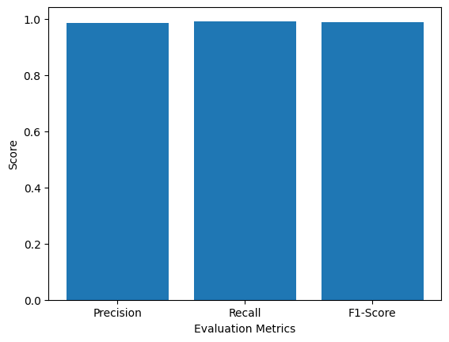
Fig.4 Precision, Recall, and F1-Score of the Proposed System

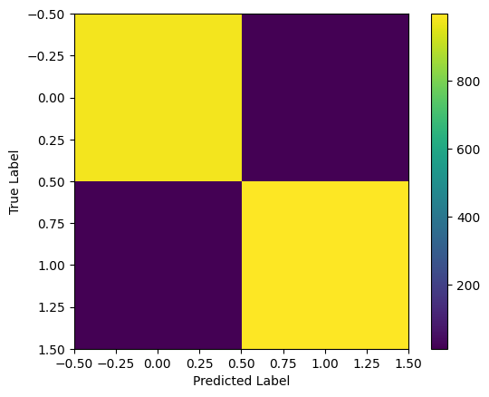
Fig.5 Confusion Matrix of the Proposed YOLOv9 Fire Detection System

The classification of the fire's severity is another important factor that the suggested system addresses. The majority of the systems that serve as the foundation for the suggested system do not take this element into account. The suggested approach may classify photos of fire as low severity, medium severity, and high severity fire in addition to classifying photographs as fire and no fire. This gives the system an additional dimension that is very helpful in emergency services decisions. The results clearly show that there is a strong correlation between the severity level of the photos and the fire activity and smoke density in those photographs. The system requires a lot of computational resources for training and real-time processing at high resolution. Additionally, processing multiple video feeds simultaneously may slow down the system. Low-visibility conditions, such as heavy fog or severe obstruction of the camera, may still pose a problem for visual fire detection. However, these limitations are common to all visual fire detection systems and can be addressed in future work. In general, the outcome of the experiment indicates that the proposed enhanced YOLOv9 fire detection system outperforms the baseline models in terms of accuracy, reliability, and usability. The integration of real-time detection, temporal validation, severity level classification, and automated alert notification systems presents a robust solution for fire monitoring in a surveillance system. The achievement of 98.8% accuracy with reduced false alarms and enhanced decision support capabilities verifies the efficacy of the proposed solution and its potential in real world applications.

CONCLUSION
This paper proposes a real-time fire detection system based on the YOLOv9 deep learning model to improve the accuracy and reliability of fire detection in the context of surveillance. The proposed system combines confidence-level detection, temporal validation, fire severity classification, and automatic emergency notification into an end-to-end solution. Compared with traditional frame-by-frame fire detection systems, it significantly reduces false positives and achieves a remarkable detection rate of 98.8%, which is robust under varying lighting conditions. The addition of fire severity classification and logging capabilities improves the system’s usability by enabling prioritized responses and analysis after the event, which are not provided in previous studies. While the advantages are evident, the model relies on vision inputs and may not perform well under extreme low visibility conditions or when resources are limited. The future plan is to expand the dataset to cover more complex fire situations optimize the model for computing at the edge include data from additional devices including heat and smoke sensors and improve dynamic models to speed up detection.

References
- Matveev, Y., Abu-Abed, F., Zhironkina, O., & Zhironkin, S. (2025). Software Supporting the Visualization of Hazardous Substance Emission Zones During a Fire at an Industrial Enterprise. Fire, 8(7), 279. https://doi.org/10.3390/fire8070279
- Danish, S., Piran, M. J., Khan, S. U., Khan, M. A., Dang, L. M., Zweiri, Y., ... & Moon, H. (2025). Vision-based fire management system using autonomous unmanned aerial vehicles: a comprehensive survey. Artificial Intelligence Review, 59(1), 16.
- Hong, T. K., & Park, S. H. (2025). Validation of Fire Dynamics Simulator Predictions Incorporating Measured Smoke Characteristics–Part 2: Smoke Concentration and Detector Characteristics in Fires. Case Studies in Thermal Engineering, 106292.
- Siva, P., Pujitha, G. B., Krishna, G. S., Hemanth, G., & Teja, B. M. S. (2025). Computer Vision Enabled Smart Surveillance for Urban Traffic Control. International Journal on Advanced Computer Engineering and Communication Technology, 14(1), 59-68.
- Aïssa, B., Hossain, M. I., Zekri, A., Abdallah, A. A., & Benito, V. B. (2025). Highly stable anti-reflection and anti-dust hard silica coating with controlled mechanical and optical properties for harsh desert environment applications. Solar Energy, 293, 113485.
- He, L., Zhou, Y., Liu, L., Zhang, Y., & Ma, J. (2025). Research and application of deep learning object detection methods for forest fire smoke recognition. Scientific Reports, 15(1), 16328.
- Elhanashi, A., Essahraui, S., Dini, P., & Saponara, S. (2025). Early fire and smoke detection using deep learning: A comprehensive review of models, datasets, and challenges. Applied Sciences, 15(18), 10255.
- Cui, X. (2025). YOLOv9, CNN, and LSTM-based solution for automated guinea pig behavior recognition.
- Nayak, K., & Dogra, D. P. (2025). A Comprehensive Review on Group Re-identification in Surveillance Videos. ACM Computing Surveys, 57(6), 1-35.
- Mathew, M., Srivastava, A., Jain, R., & Saxena, P. (2025). Characterization of Chemical Constituents in Acidic Fog. In Fog: Formation, Chemistry, Dynamics, Impact and Dissipation (pp. 59-82). Singapore: Springer Nature Singapore.
- Boddapati, M. S. D., Desamsetti, S. A., Adina, K., Uppalapati, P. J., Murty, P. S., & PB V, R. (2023, August). Creating a protected virtual learning space: a comprehensive strategy for security and user experience in online education. In International Conference on Cognitive Computing and Cyber Physical Systems (pp. 350-361). Cham: Springer Nature Switzerland.
- Xu, Z., & Chen, Z. (2024). Investigation of noise characteristics of electric vibrator utilizing acoustic camera and transfer path analysis. Measurement Science and Technology, 35(11), 116012.
- Zhou, M., Zhou, B., Zhang, Z., Zhou, Z., Liu, J., Li, B., ... & Wu, T. (2023). Fire egress system optimization of high-rise teaching building based on simulation and machine learning. Fire, 6(5), 190. https://doi.org/10.3390/fire6050190
- Khan, R. A., Hussain, A., Bajwa, U. I., Raza, R. H., & Anwar, M. W. (2023). Fire and smoke detection using capsule network. Fire Technology, 59(2), 581-594.
- Abarca, L. L. M., Barros, A. L. B. L. D., Baptista, R. C. N., Batista, R. E. A., & Lopes, J. D. L. (2023). Effect of video on satisfaction and self-confidence in simulation training: a randomized clinical trial. Revista Brasileira de Enfermagem, 76, e20220366. https://doi.org/10.1590/0034-7167-2022-0366
- Vanini, C., Hargreaves, C. J., van Beek, H., & Breitinger, F. (2024). Was the clock correct? Exploring timestamp interpretation through time anchors for digital forensic event reconstruction. Forensic Science International: Digital Investigation, 49, 301759. https://doi.org/10.1016/j.fsidi.2024.301759
- Raschka, S., Liu, Y. H., & Mirjalili, V. (2022). Machine Learning with PyTorch and Scikit-Learn: Develop machine learning and deep learning models with Python. Packt Publishing Ltd.
- Ding, X., Zhao, L., & Akoglu, L. (2022). Hyperparameter sensitivity in deep outlier detection: Analysis and a scalable hyper-ensemble solution. Advances in Neural Information Processing Systems, 35, 9603-9616.
- Yaseen, M. (2024). What is YOLOv9: An in-depth exploration of the internal features of the next-generation object detector. arXiv preprint arXiv:2409.07813.
- Huang, R., Wei, W., Qu, X., Zhang, S., Chen, D., & Cheng, Y. (2024, August). Confidence is not timeless: Modeling temporal validity for rule-based temporal knowledge graph forecasting. In Proceedings of the 62nd Annual Meeting of the Association for Computational Linguistics (Volume 1: Long Papers) (pp. 10783-10794).

